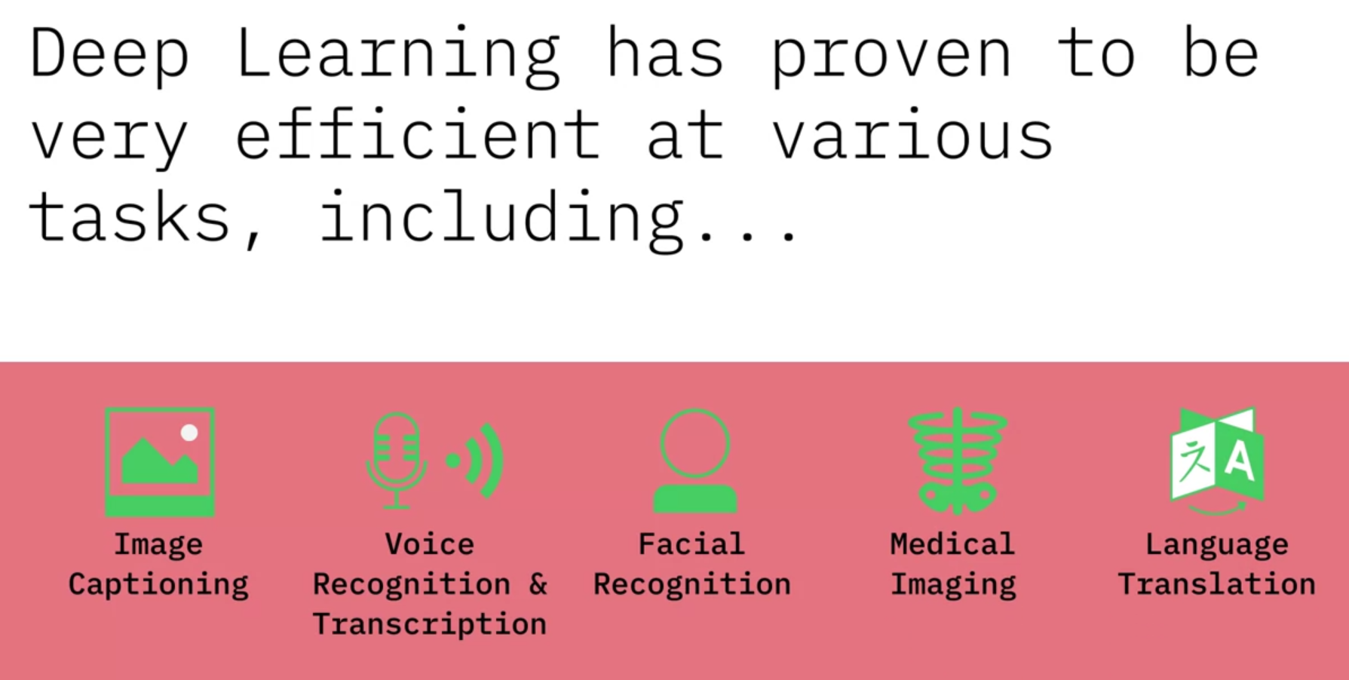

+ driverless cars.

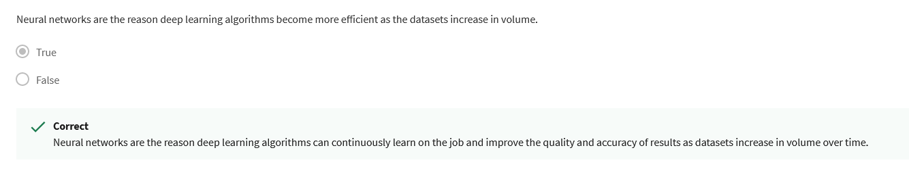

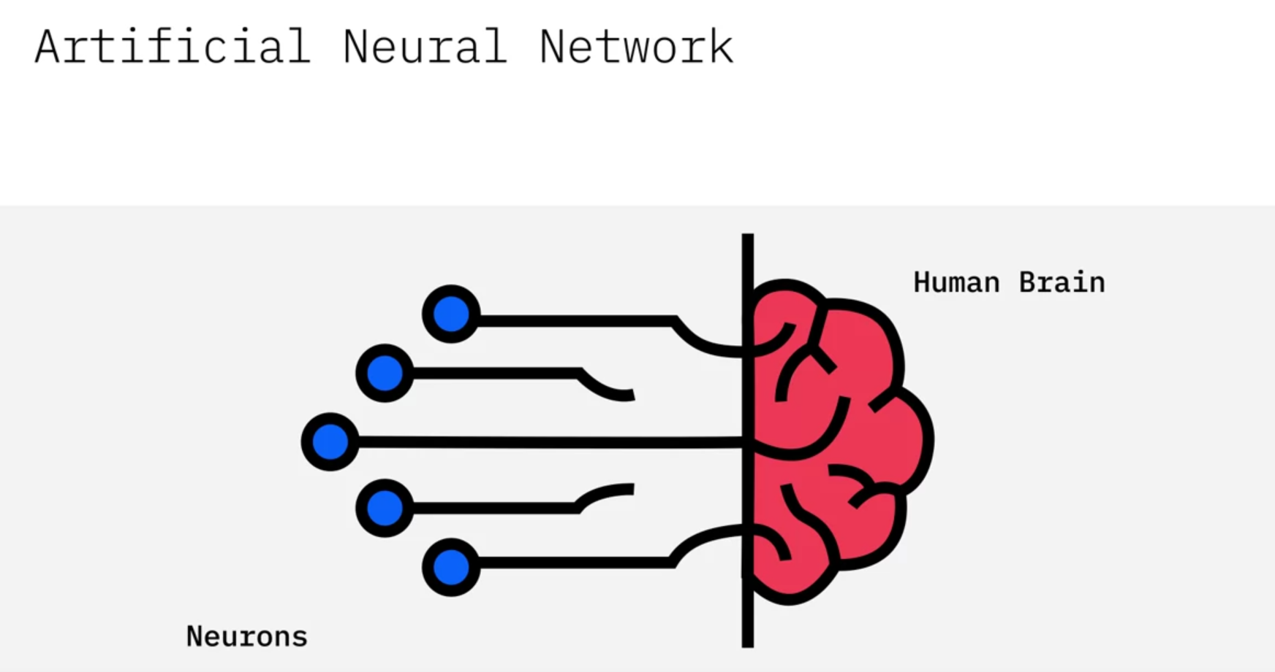

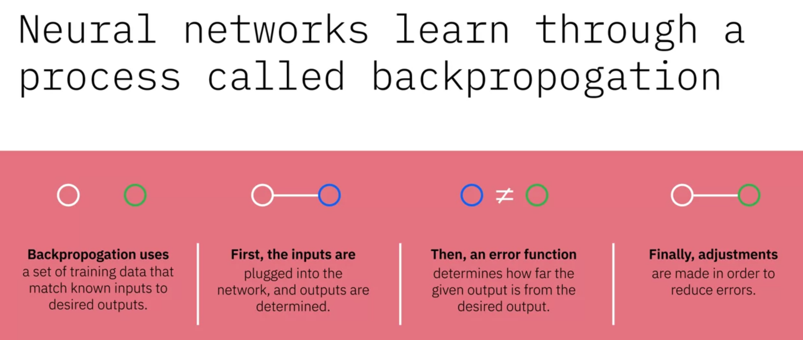

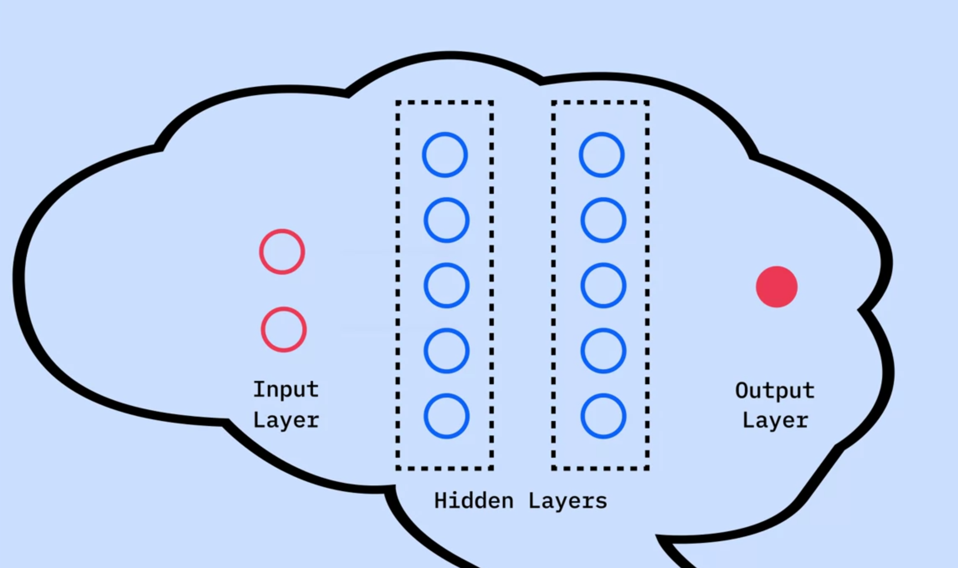

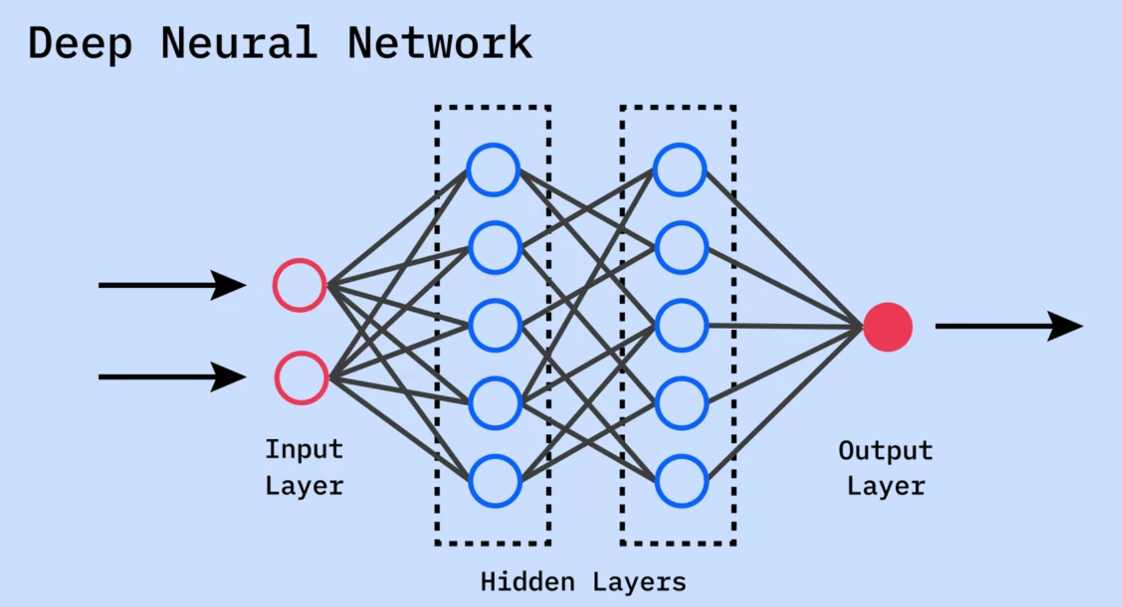

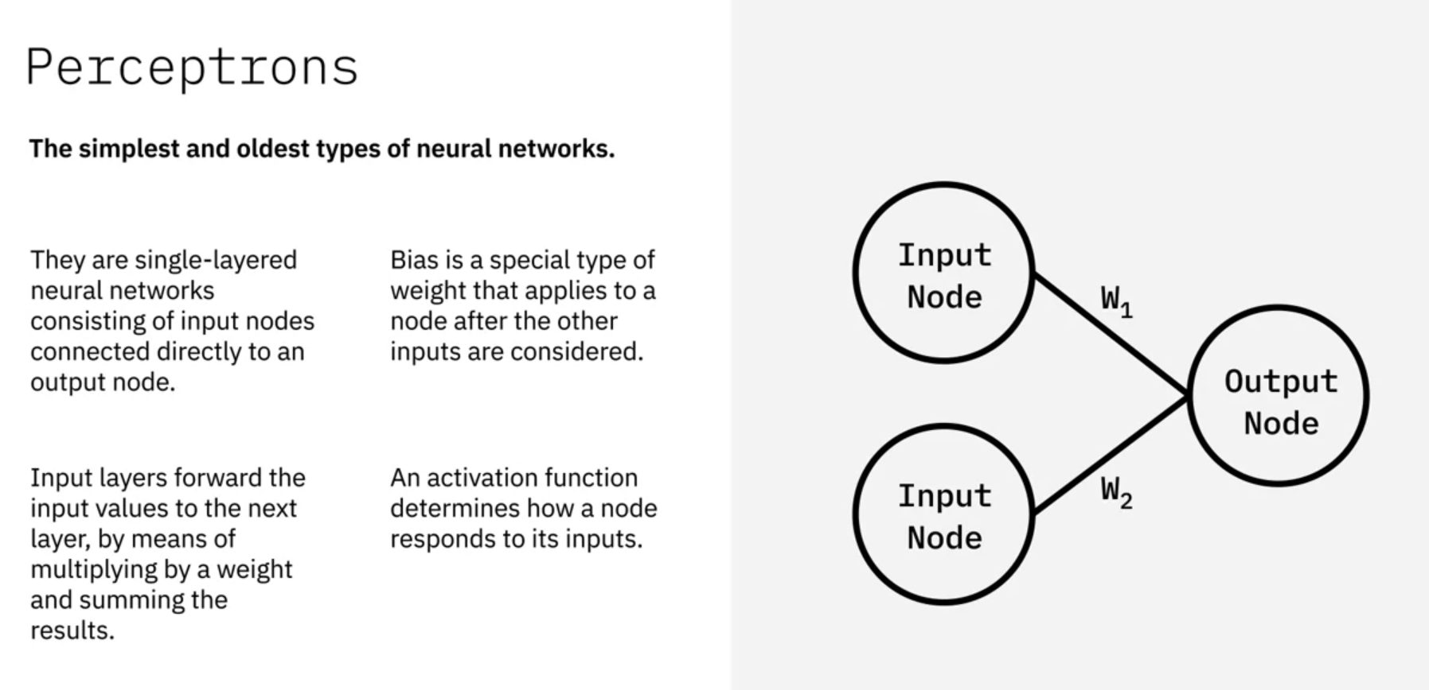

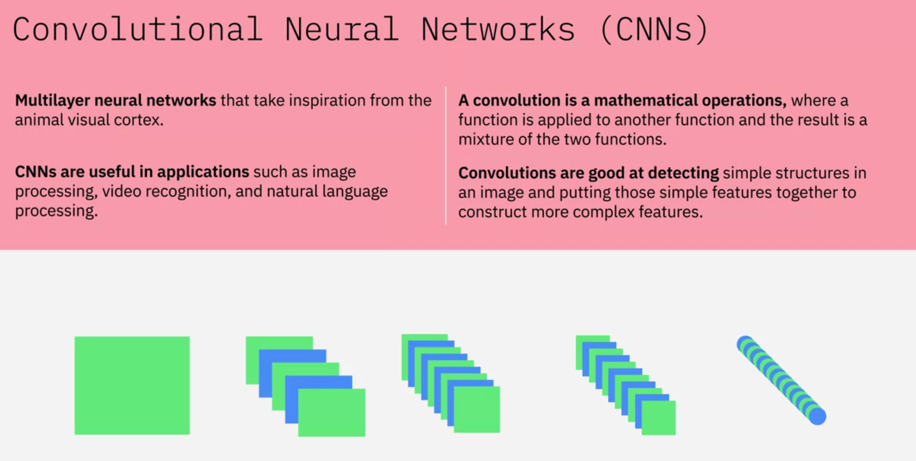

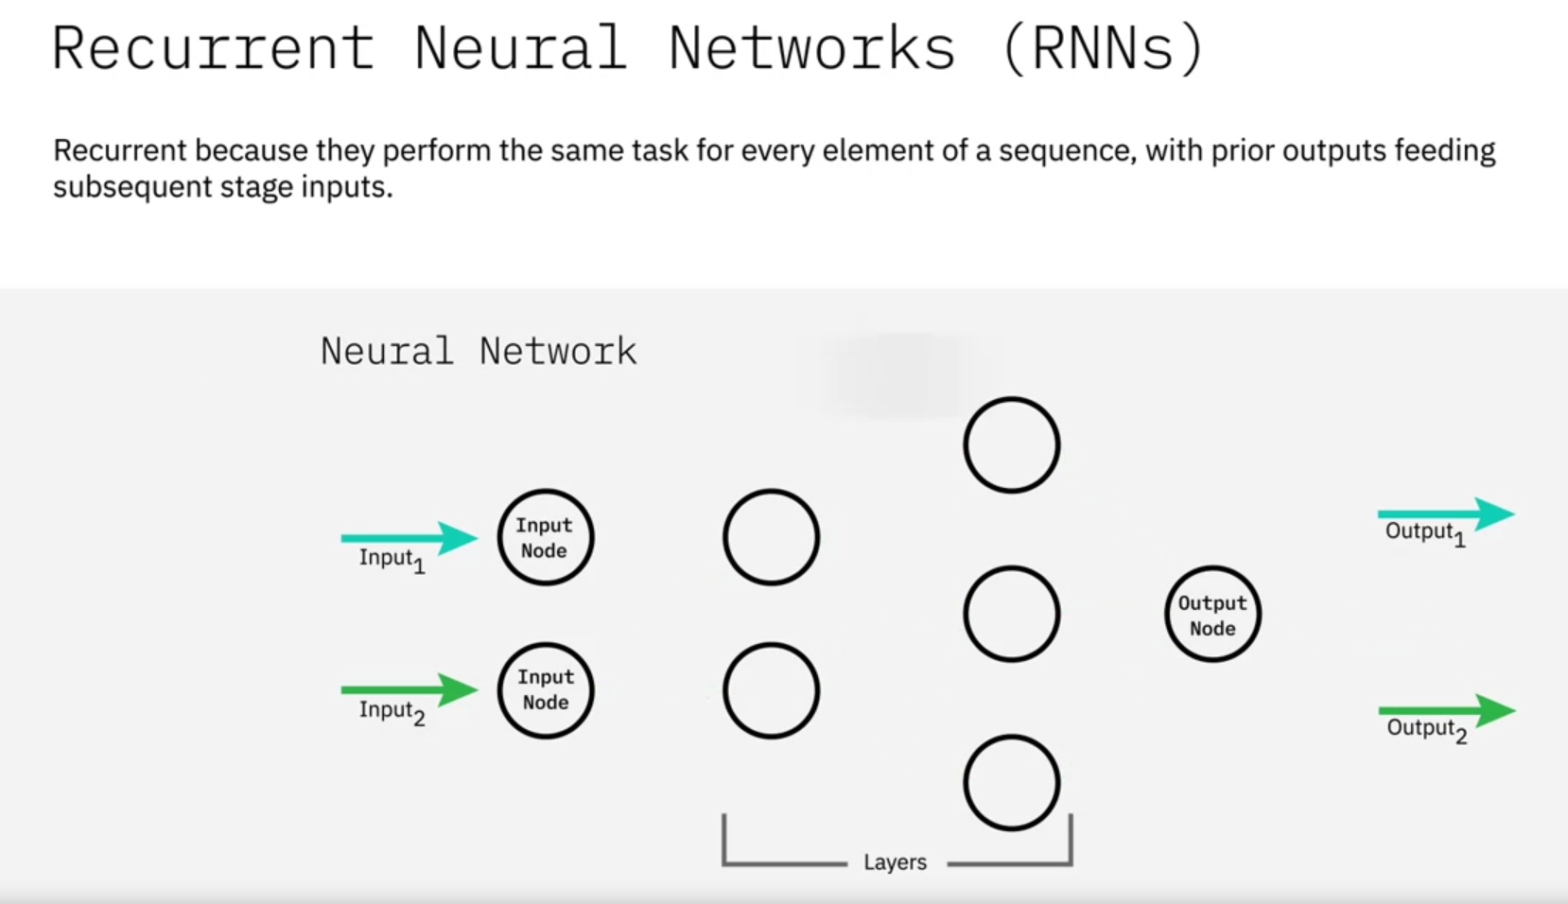

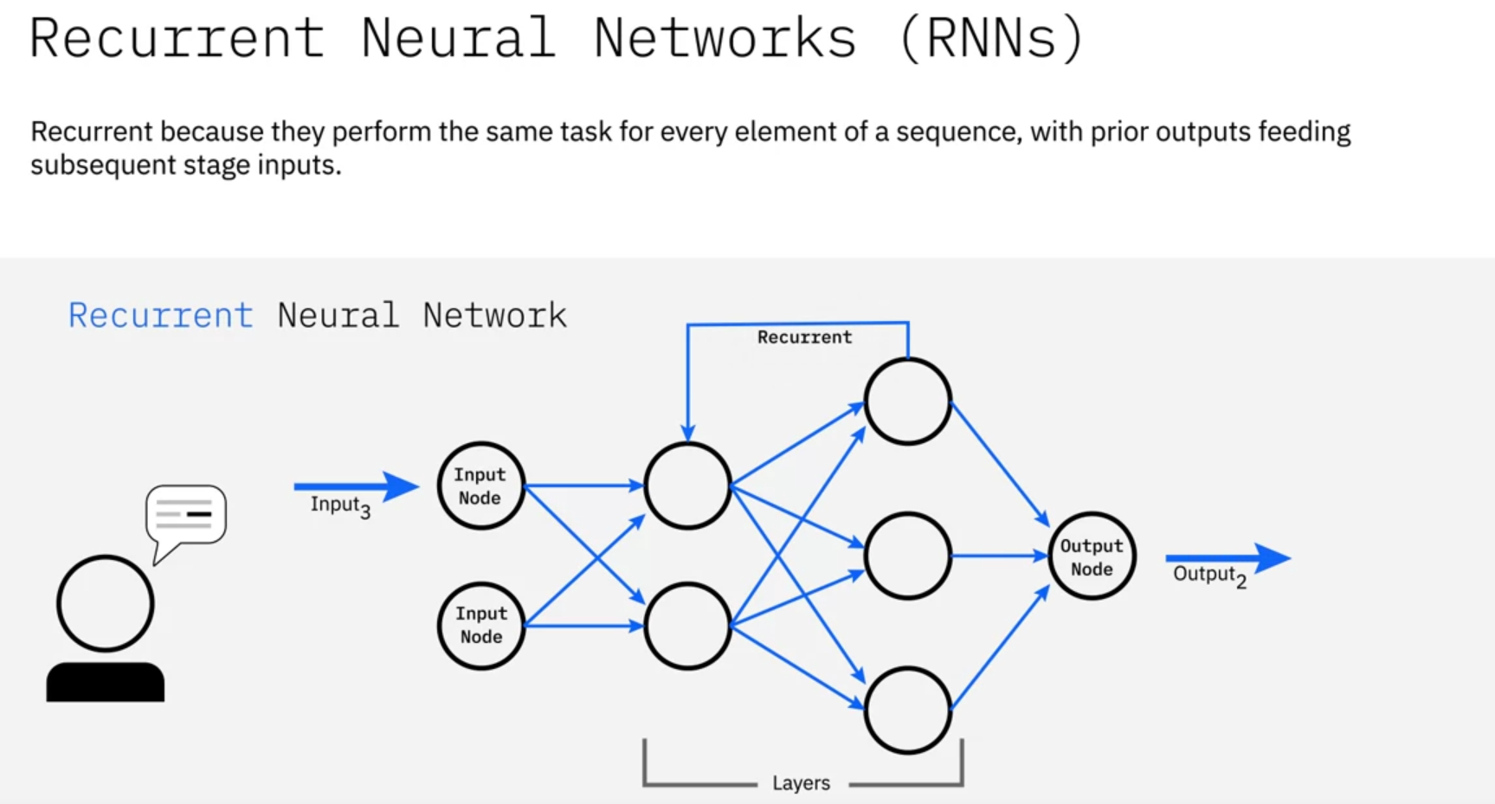

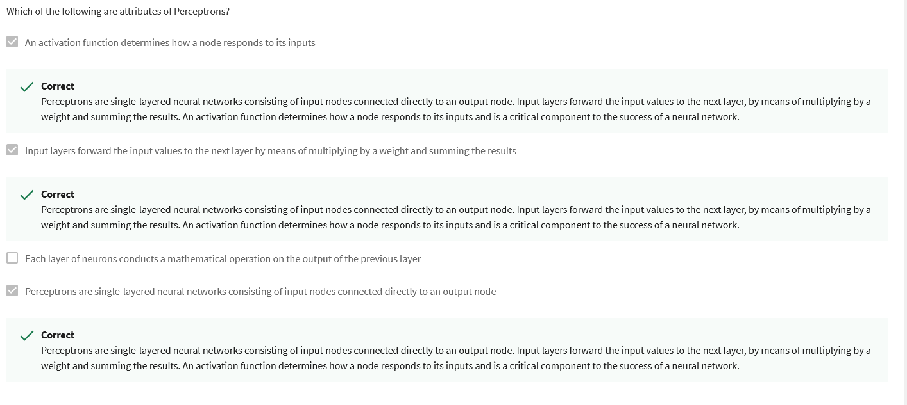

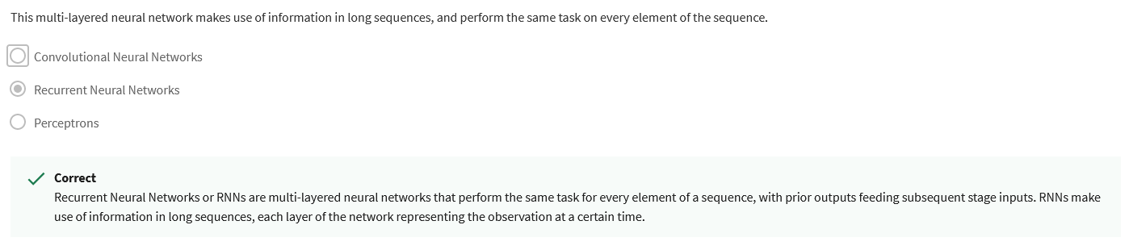

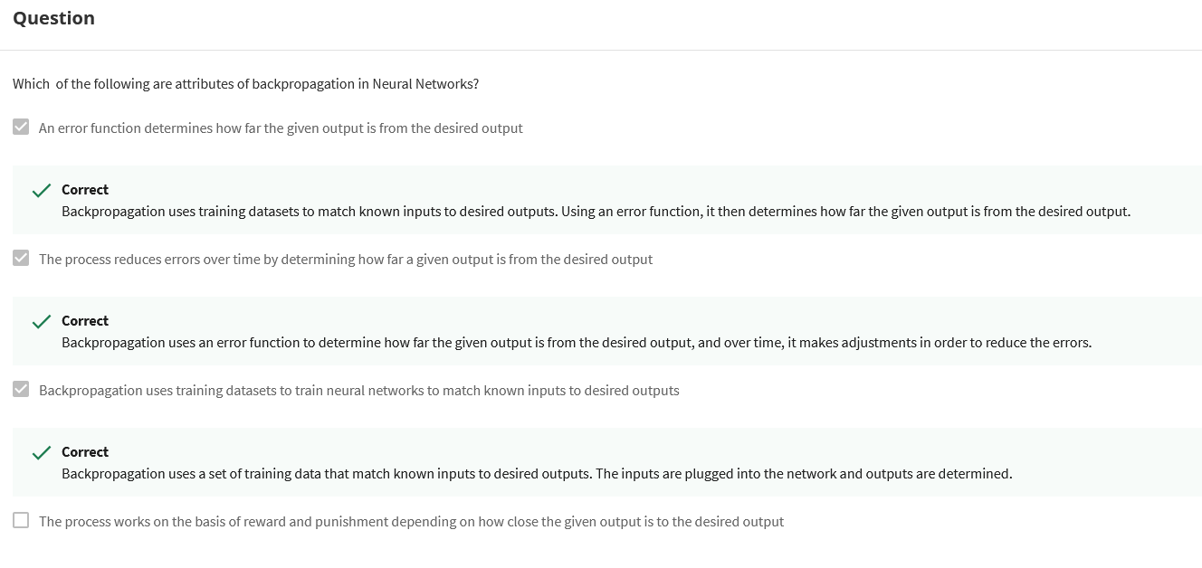

### In this lesson, you have learned:

* Machine Learning, a subset of AI, uses computer algorithms to analyze data and make intelligent decisions based on what it has learned. The three main categories of machine learning algorithms include Supervised Learning, Unsupervised Learning, and Reinforcement learning.
* Deep Learning, a specialized subset of Machine Learning, layers algorithms to create a neural network enabling AI systems to learn from unstructured data and continue learning on the job.
* Neural Networks, a collection of computing units modeled on biological neurons, take incoming data and learn to make decisions over time. The different types of neural networks include Perceptrons, Convolutional Neural Networks or CNNs, and Recurrent Neural Networks or RNNs.

### In the Machine Learning Techniques and Training topic, you have learned:

* Supervised Learning is when we have class labels in the data set and use these to build the classification model.
* Supervised Learning is split into three categories – Regression, Classification, and Neural Networks.
* Machine learning algorithms are trained using data sets split into training data, validation data, and test data.

### [Optional] To learn more about Machine Learning, Deep Learning, and Neural Networks, read these articles:

* [Models for Machine Learning](https://developer.ibm.com/articles/cc-models-machine-learning/)
* [Applications of Deep Learning](https://www.ibm.com/blogs/think/category/deep-learning)
* [A Neural Networks deep dive](https://developer.ibm.com/articles/cc-cognitive-neural-networks-deep-dive/?mhq=neural%20networks&mhsrc=ibmsearch_a)

# **Key Fields of Application in AI**

Natural language is one of the most complex data for machine learning to work with. Natural language is highly contextualized, moreover humans view and use language conceptually rather than literally. Other types of data, be it auditory or visual data, have some form of discernible patterns, making it easier to work with than natural language.

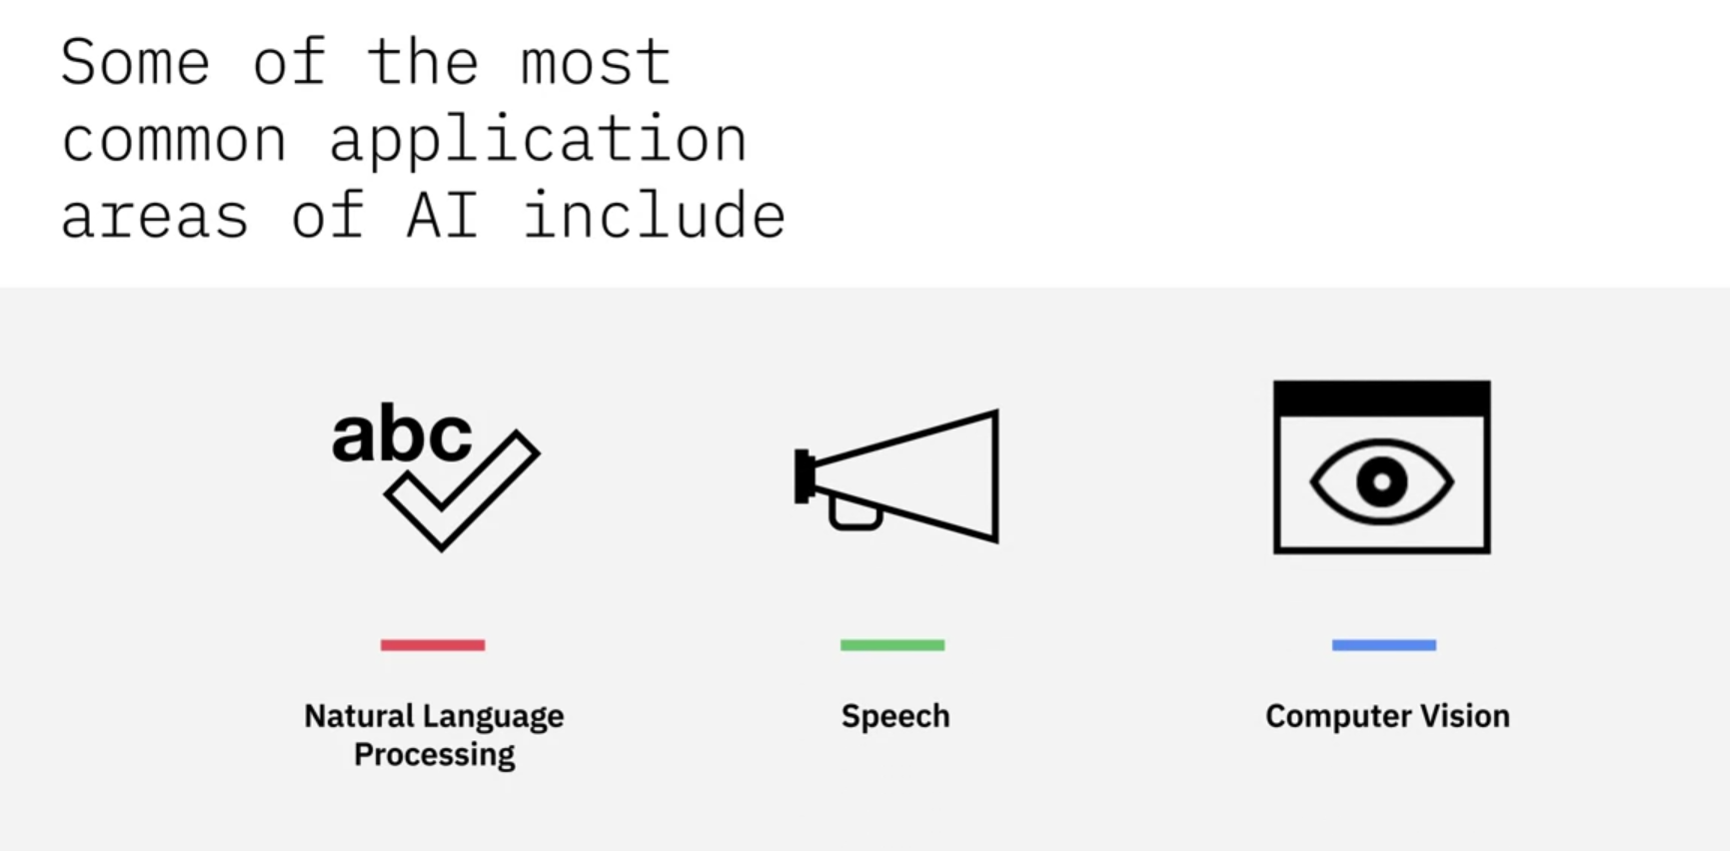

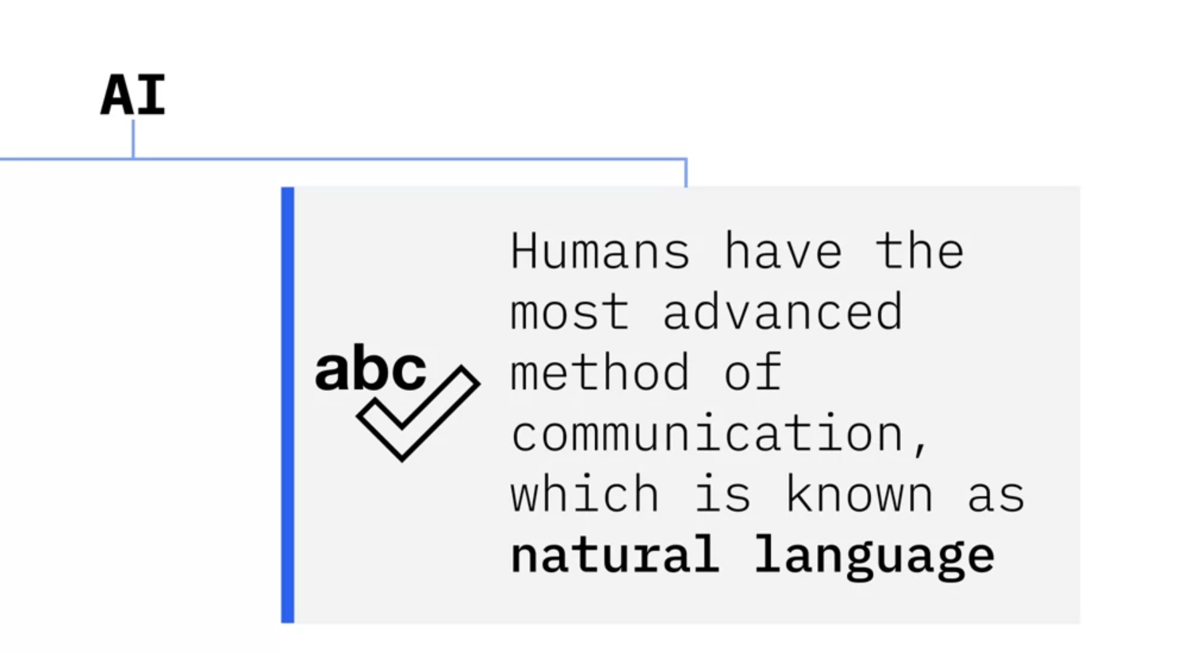

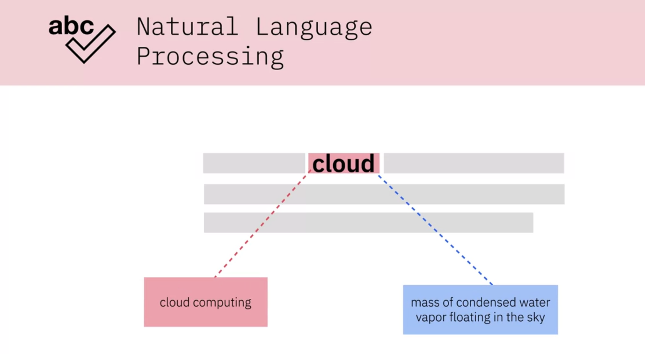

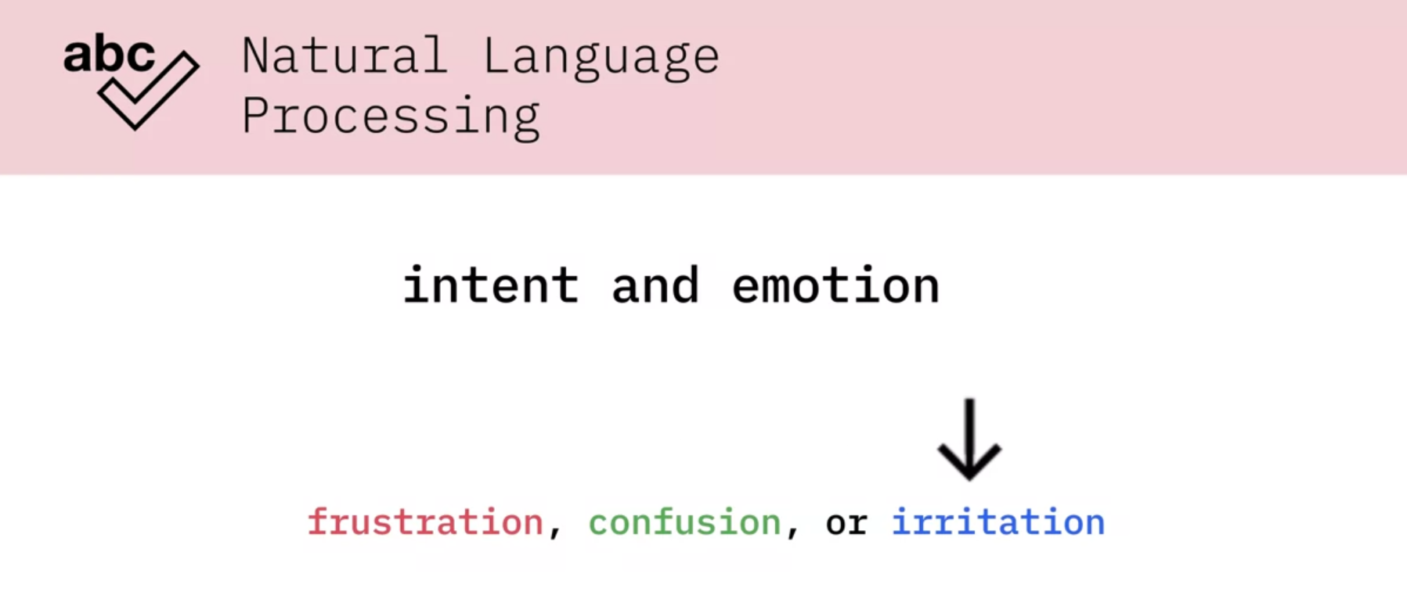

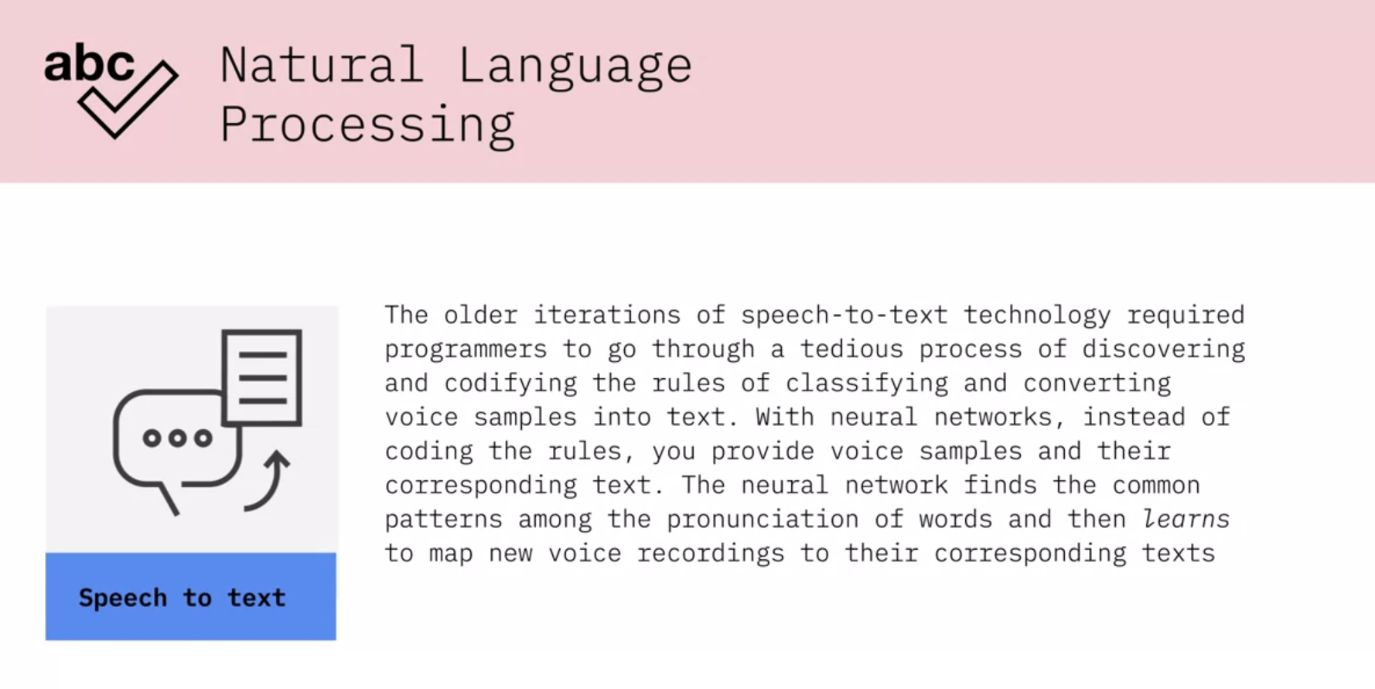

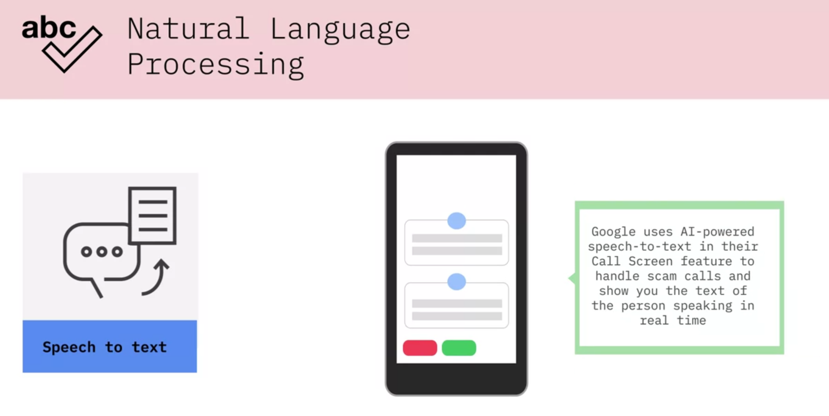

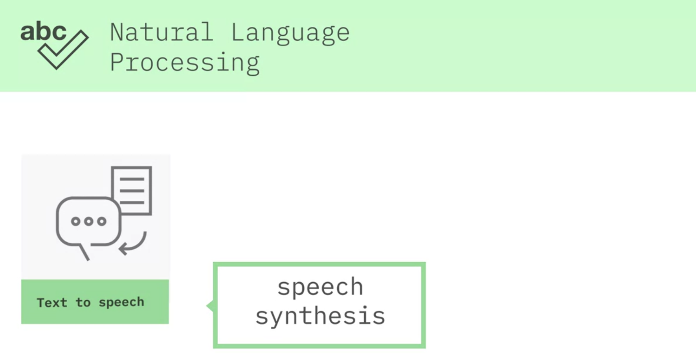

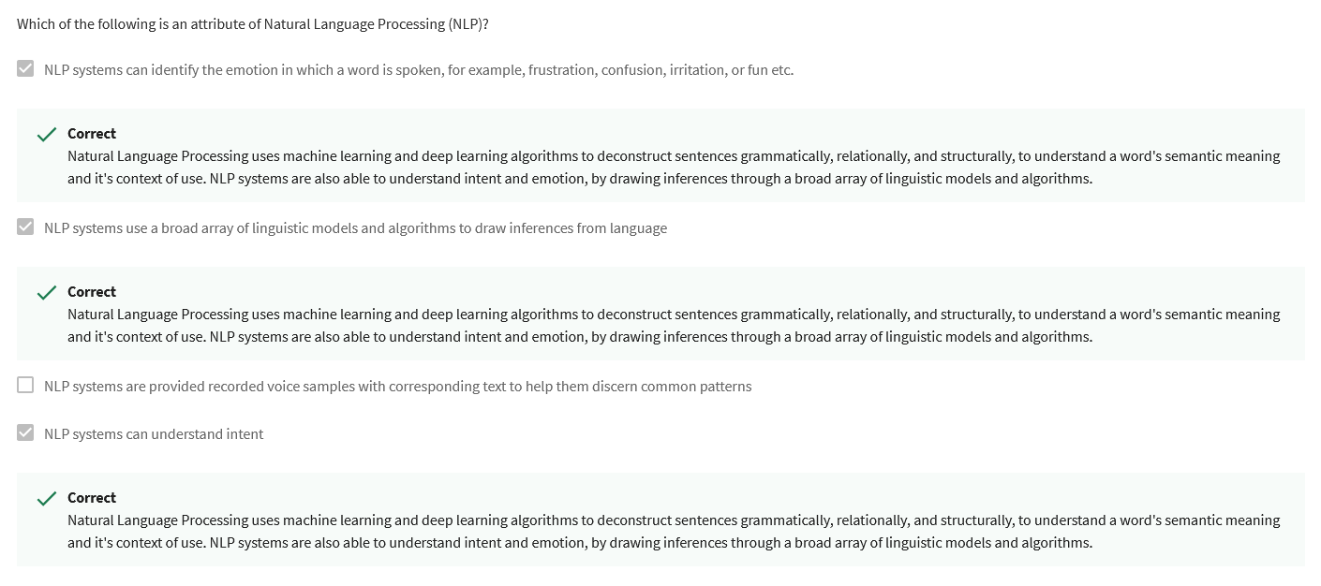

Self-driving vehicles fuse laser data, vision data, and radar data to create a three-dimensional view of their driving environment helping them make accurate decisions on the road.

### In this lesson, you have learned:

* Natural Language Processing (NLP) is a subset of artificial intelligence that enables computers to understand the meaning of human language, including the intent and context of use.
* Speech-to-text enables machines to convert speech to text by identifying common patterns in the different pronunciations of a word, mapping new voice samples to corresponding words.
* Speech Synthesis enables machines to create natural sounding voice models, including the voice of particular individuals.
* Computer Vision enables machines to identify and differentiate objects in images the same way humans do.
* Self-driving cars is an application of AI that can utilize NLP, speech, and most importantly, computer vision.

### To learn more about Natural Language Processing, read this article:

* [A beginner's guide to Natural Language Processing](https://developer.ibm.com/articles/a-beginners-guide-to-natural-language-processing/)

**Week 3**

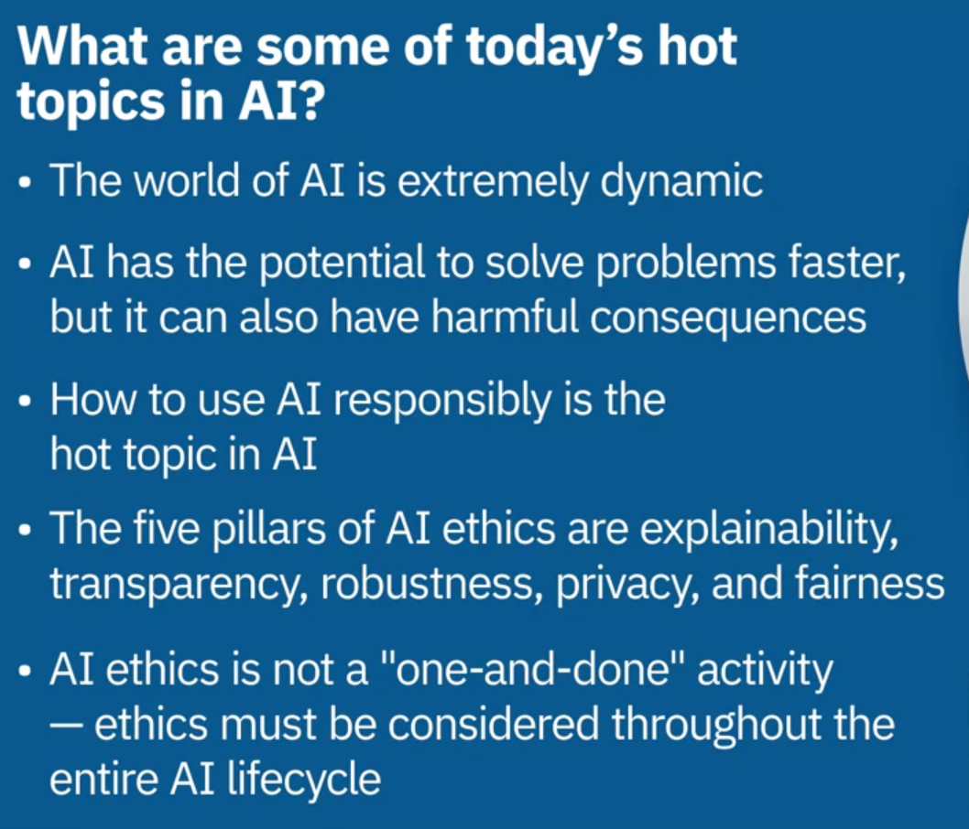

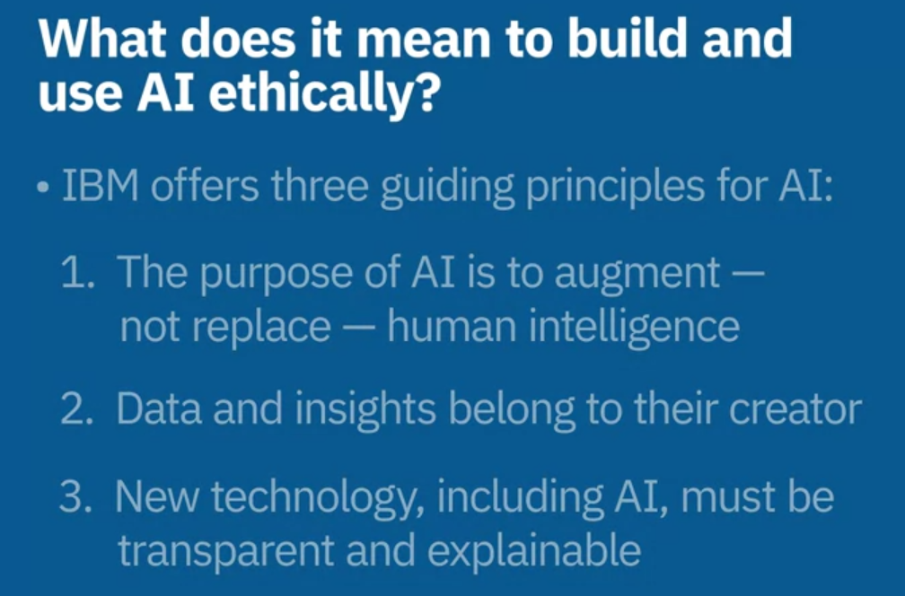

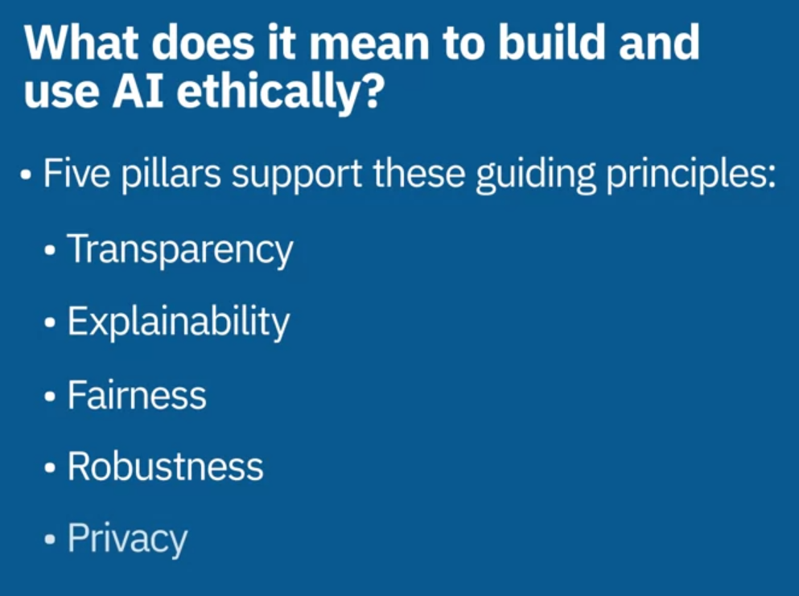

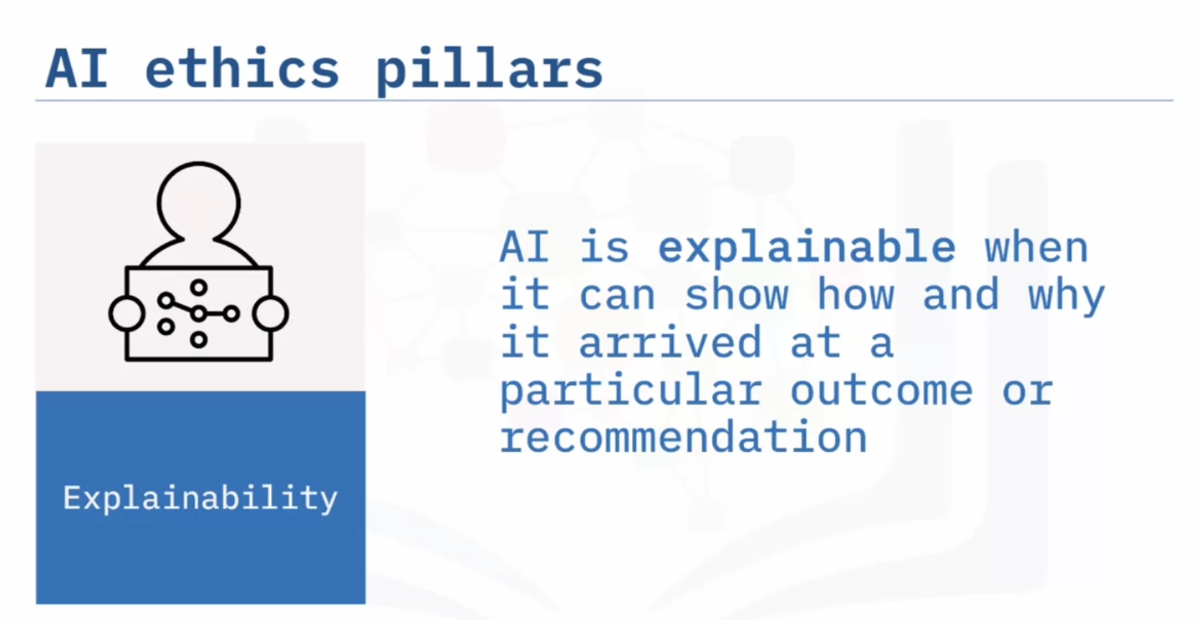

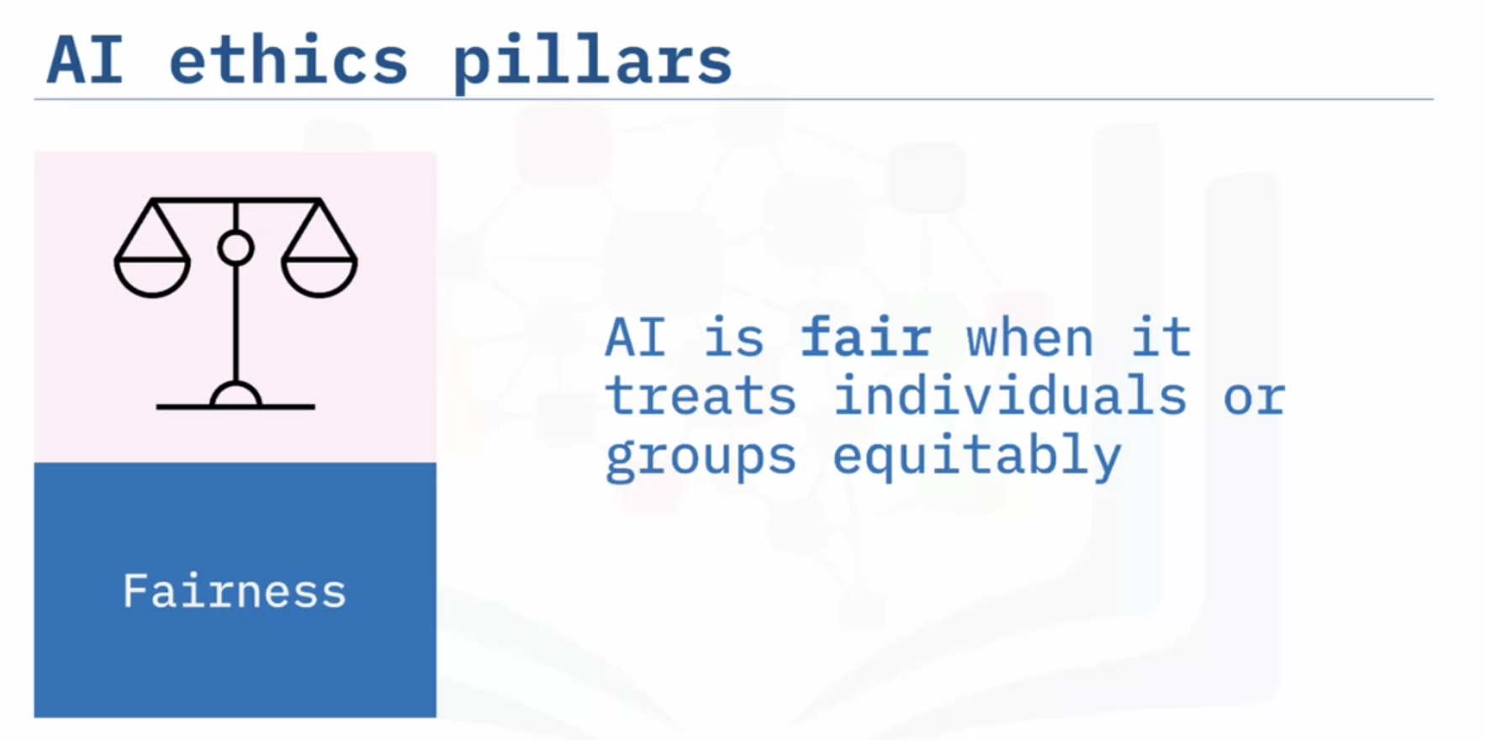

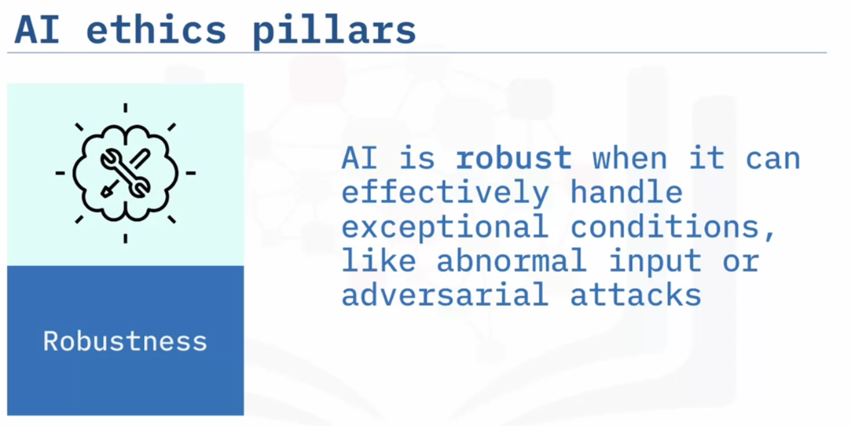

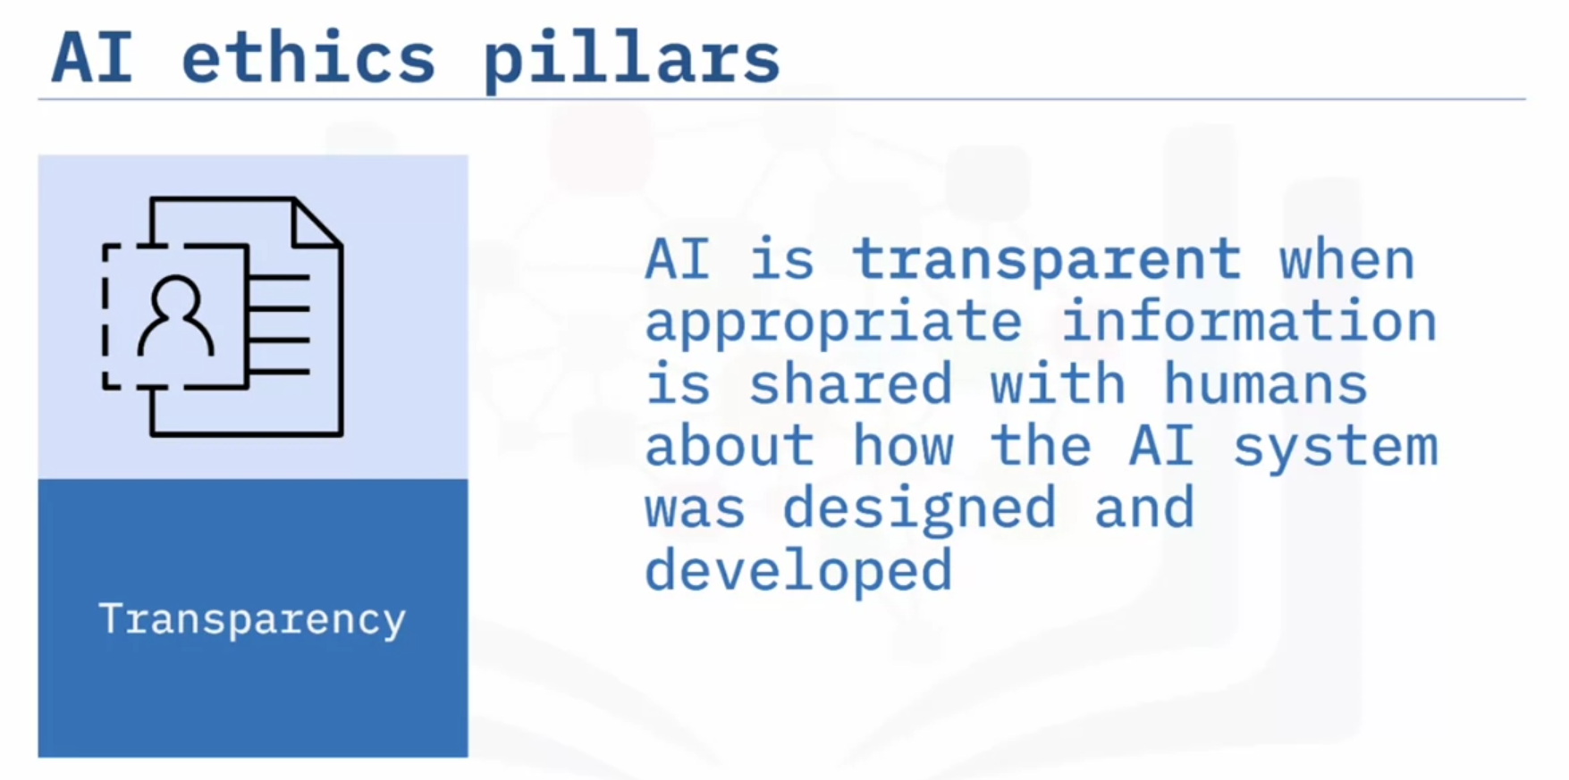

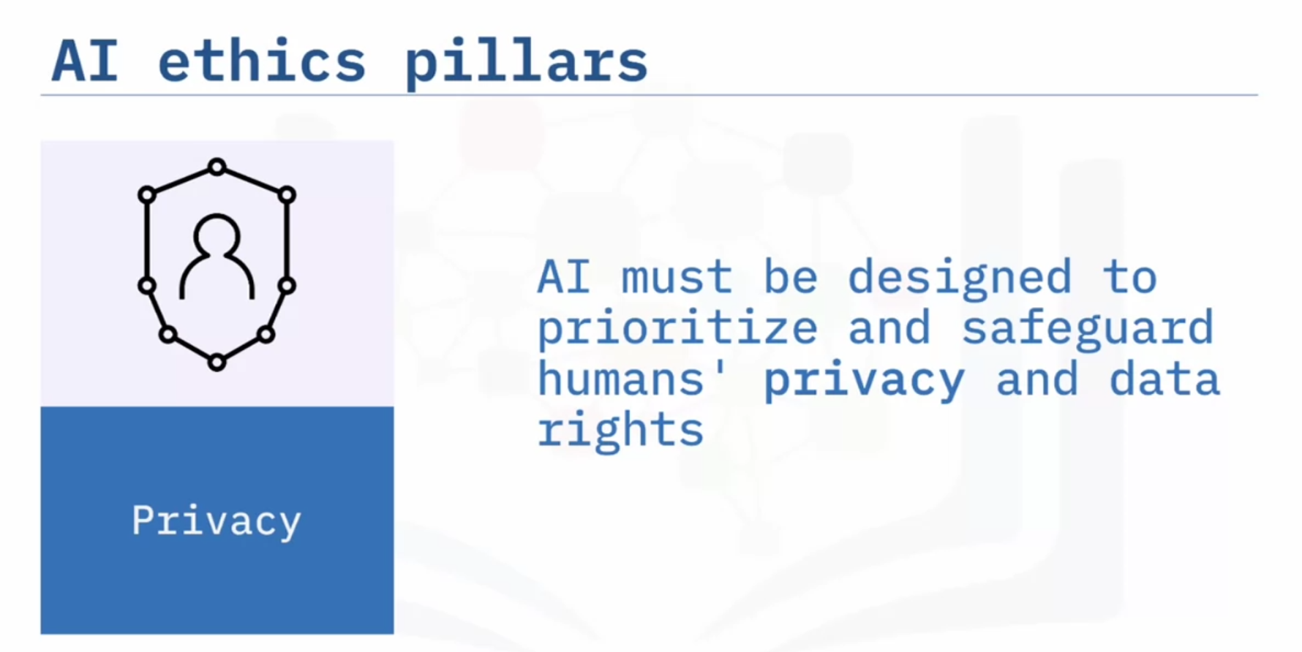

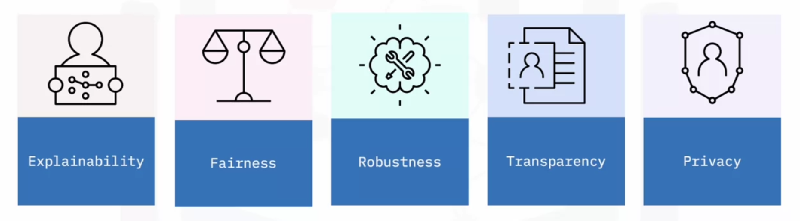

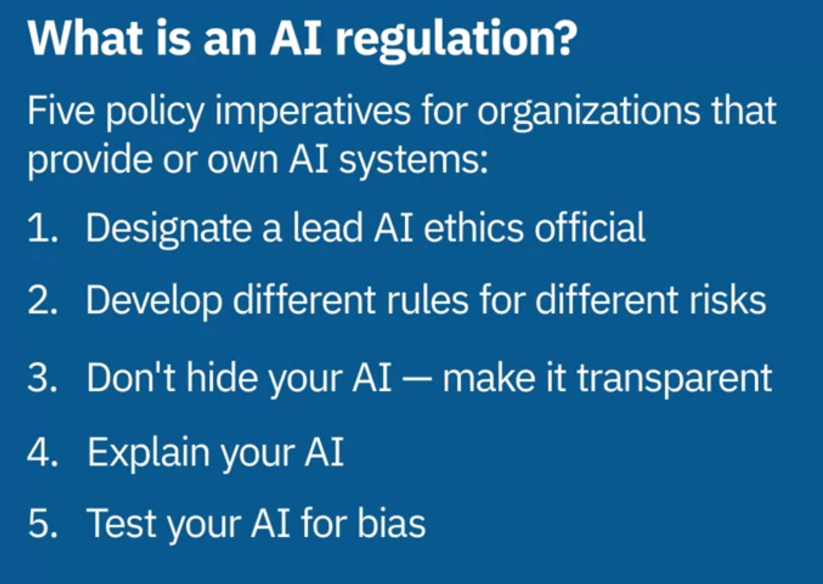

In this lesson, you have learned:

* Today's AI issues and concerns include how to build and use AI responsibly and how AI is used in healthcare, facial recognition, social media and marketing, and hiring
* AI ethics is a multidisciplinary field that investigates how to optimize AI's beneficial impact while reducing risks and adverse impacts
* AI ethics is a "socio-technical" challenge, meaning that it cannot be solved by tools alone
* AI ethics principles are:
  + The purpose of AI is to augment — not replace — human intelligence
  + Data and insights belong to their creator
  + New technology must be transparent and explainable
* AI ethics pillars are:
* Explainability: The ability of an AI system to provide insights that humans can use to understand the causes of the system's predictions.
  + Fairness: The equitable treatment of individuals or groups of individuals.
  + Robustness: The ability of an AI system to effectively handle exceptional conditions, such as abnormal input or adversarial attacks.
  + Transparency: Sharing appropriate information with stakeholders on how an AI system has been designed and developed.
  + Privacy: AI systems must prioritize and safeguard consumers’ privacy and data rights.
* In AI, bias gives systematic disadvantages to certain groups or individuals
* One potential cause of bias in AI is the implicit or explicit biases of the people who design and develop AI
* One way to mitigate bias is to assemble diverse teams
* Regulations are government rules enforcible by law.
* AI governance is an organization's act of governing, through its corporate instructions, staff, processes and systems

To learn more about AI ethics, visit:

* [IBM AI Ethics homepage](https://www.ibm.com/artificial-intelligence/ethics)
* [IBM Trustworthy AI homepage](https://www.ibm.com/watson/trustworthy-ai)
* [IBM Policy Lab](https://www.ibm.com/policy/)
* [Good Tech IBM](https://www.ibm.com/blogs/corporate-social-responsibility/)